USER WEBSITE GUIDELINES

1. HOMEPAGE
2. LOGIN PAGE
3. REGISTER PAGE
4. EMAIL VERIFICATION
5. USER PROFILE
6. SHOP
7. PRODUCT FILTER BY SHOP TYPE
8. PRODUCT FITLER BY FOOD TYPE
9. SEARCH PRODUCT
10. SINGLE PRODUCT -> Reviews, Rating
11. FAVOURITES
12. CART
13. CHECKOUT DETAILS
14. ORDER PLACE
15. CONFIRMED ORDER INVOICE
16. PAYPAL LOGIN
17. ORDER SUCCESS
18. COLLECTION SLOT CHOOSE
19. PRODUCT INVOICE

HOMEPAGE: As the user first visits the website, this page is shown.

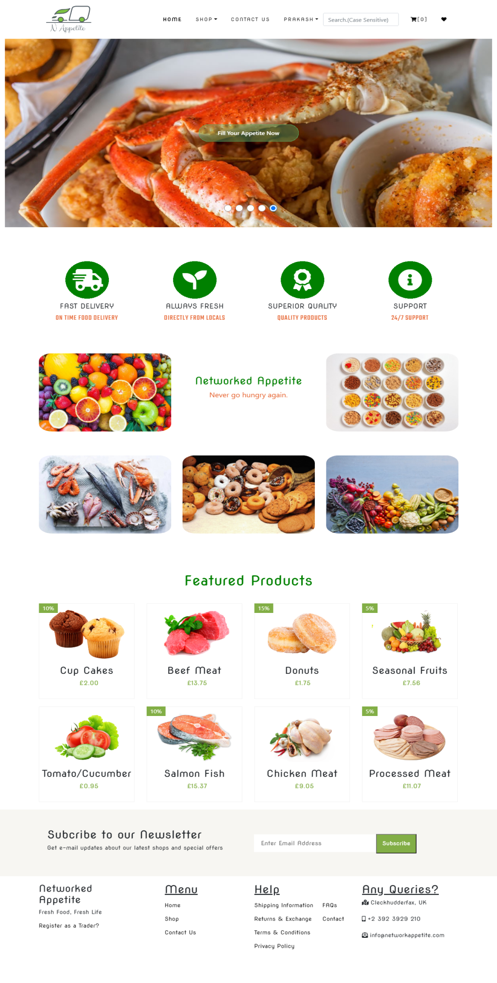

REGISTRATION PAGE: This is the registration page from where user can register. All the fields are required. Password should contain at least one number, one lowercase and 1 uppercase letter and minimum length should be 8 characters.

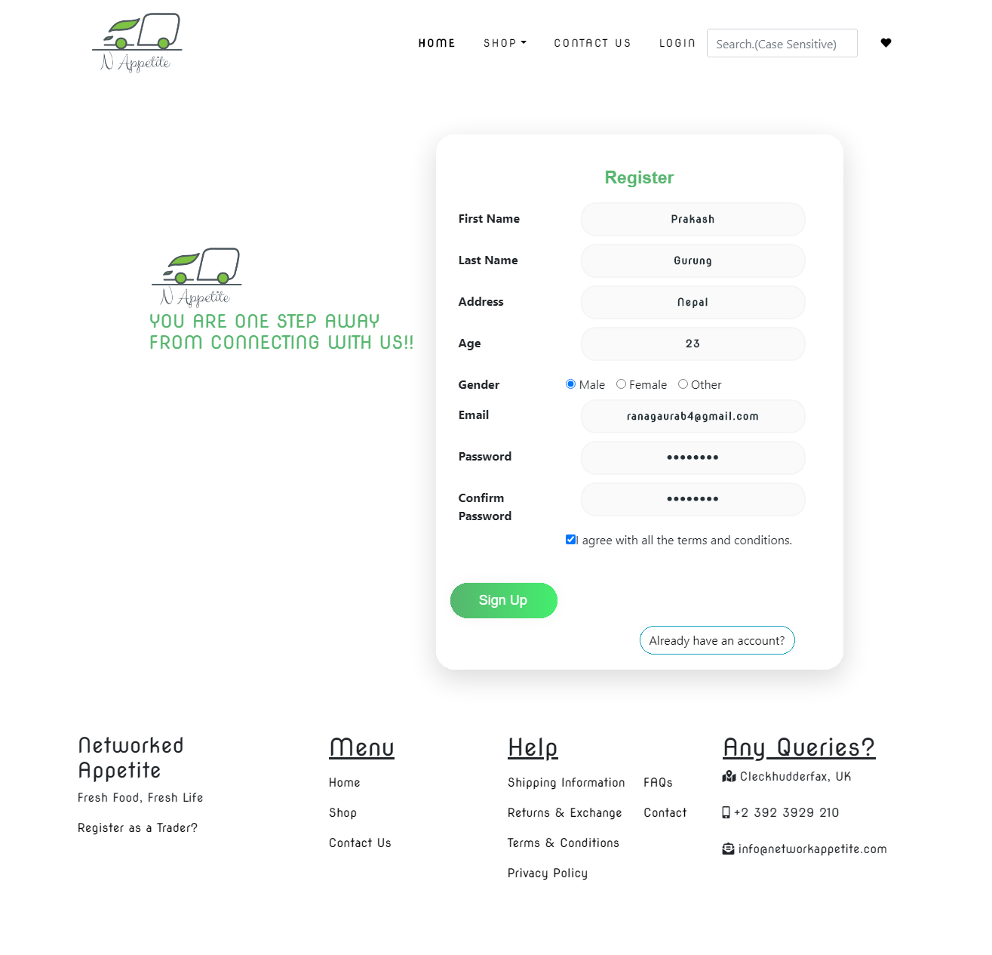

After Successful Registration User will get notice for email verification.

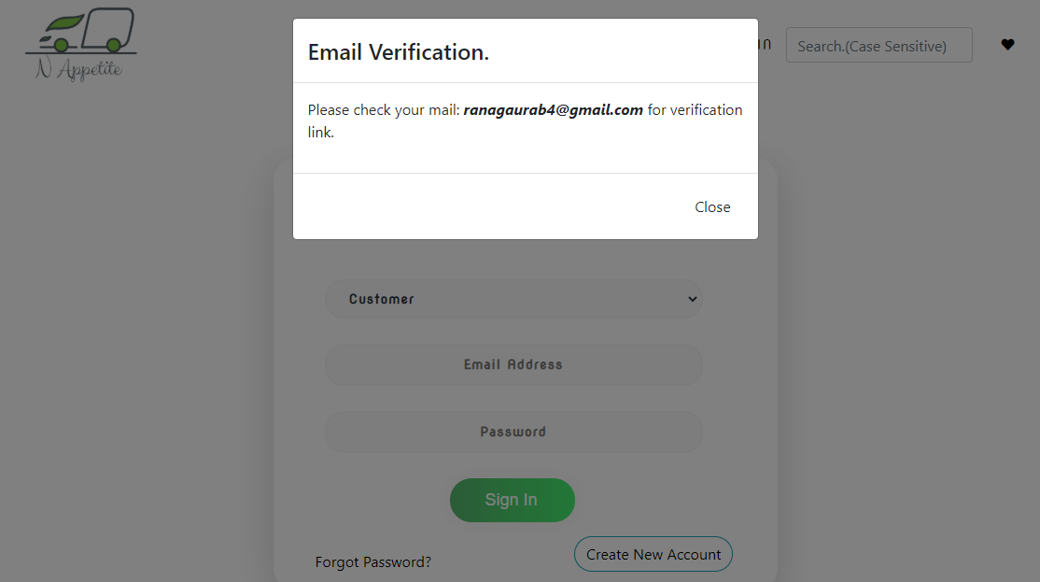

Then User have to click on the link sent to their email.

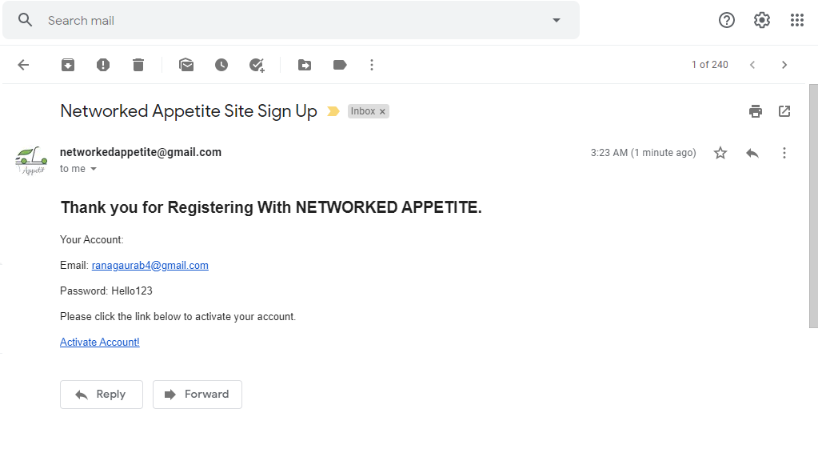

Clicking the link will verify the email. 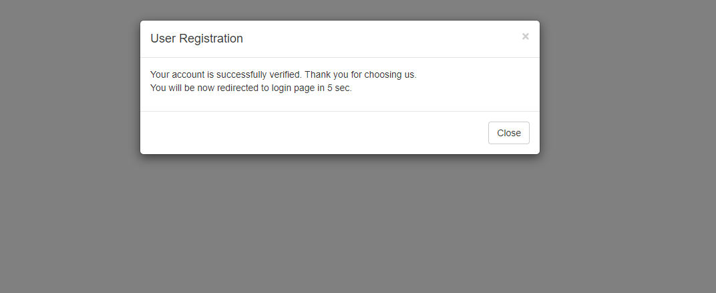

After this page, the user is redirected to login page and then user can login to their account.

**LOGIN PAGE**: This is the login page from where user can login to the website. Email address and password are required.

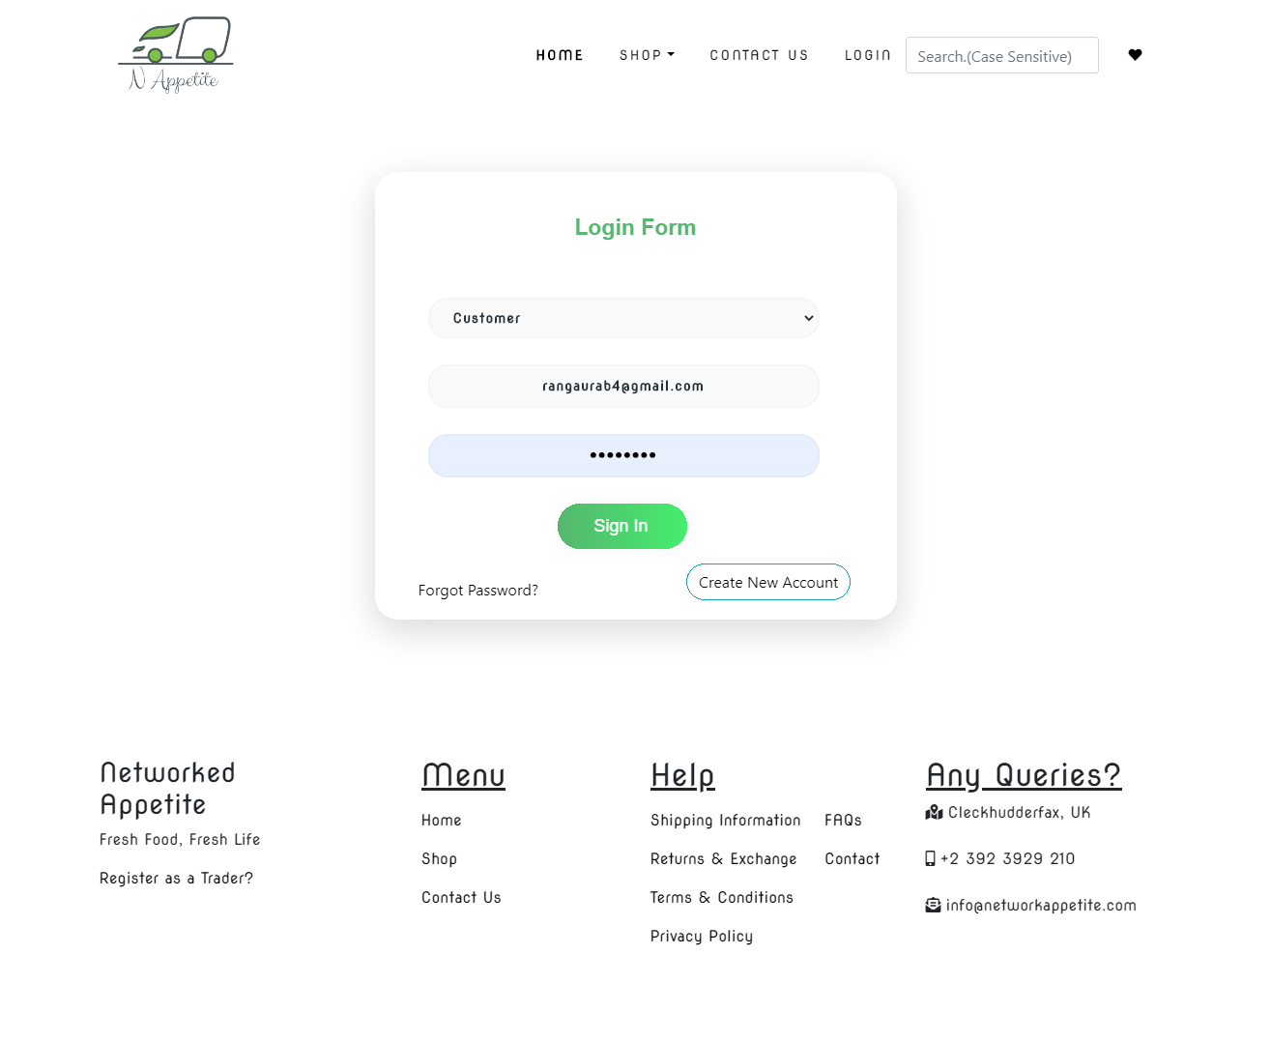

As the user login, they are redirected to shopping page.

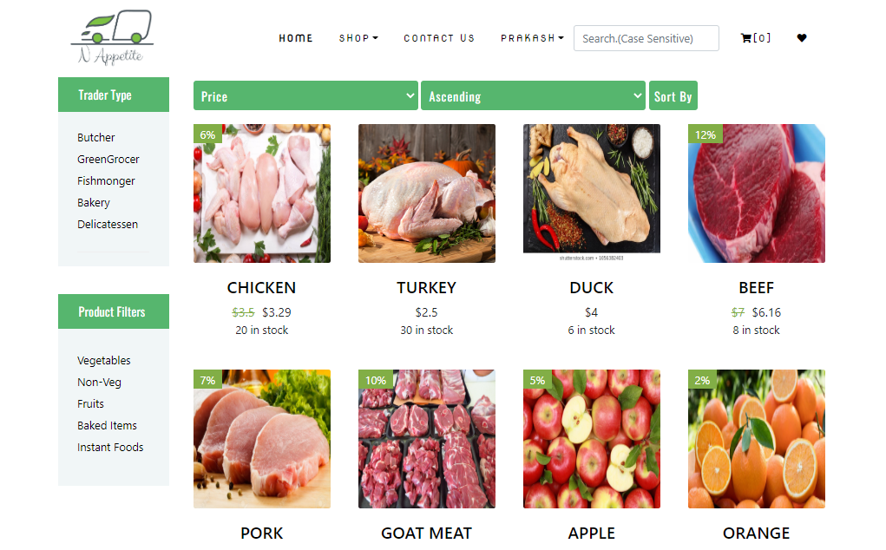

FILTER BY TRADER TYPE: TraderType Filter will show related products as below.

BUTCHER :

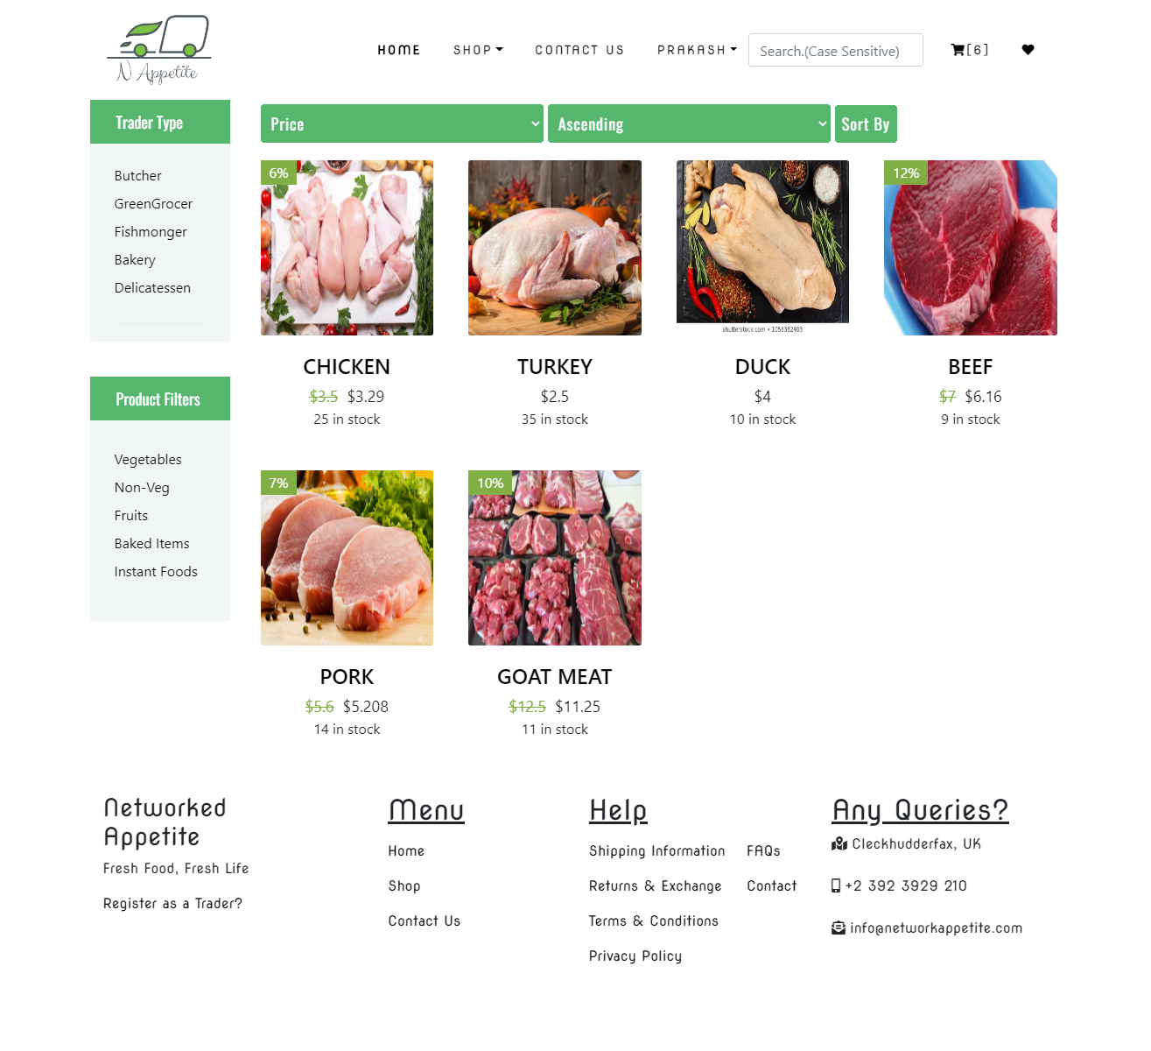

BAKERY

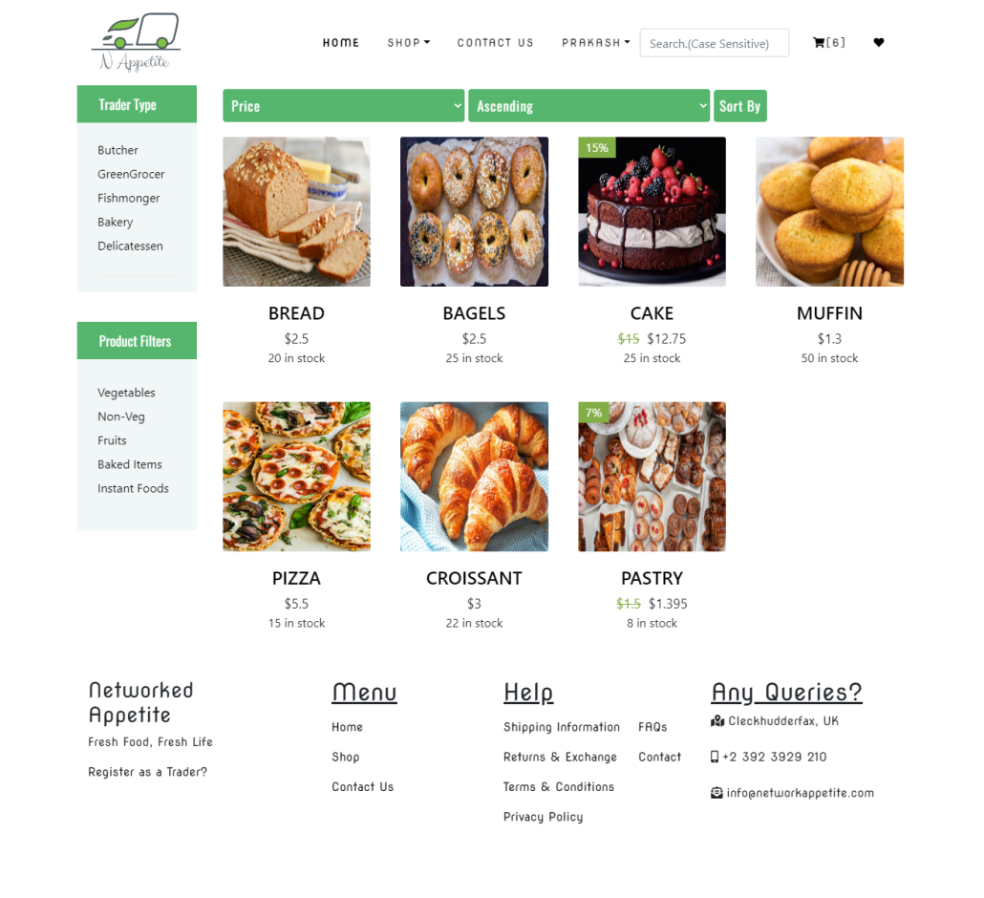

FISHMONGER

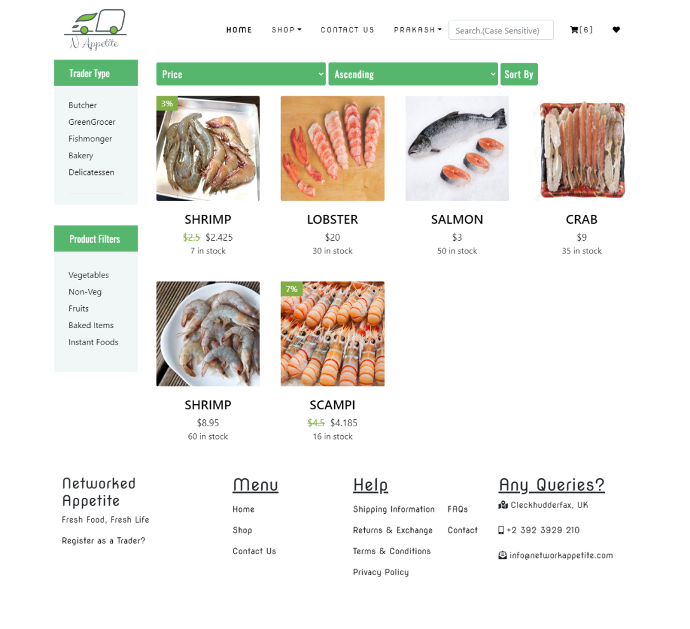

GREENGROCER

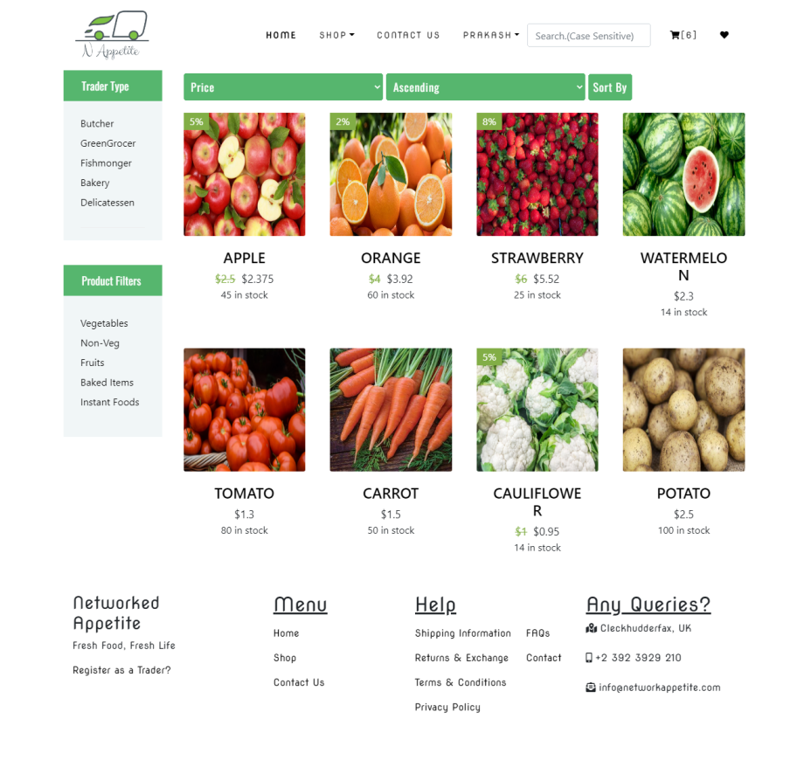

DELICATESSEN

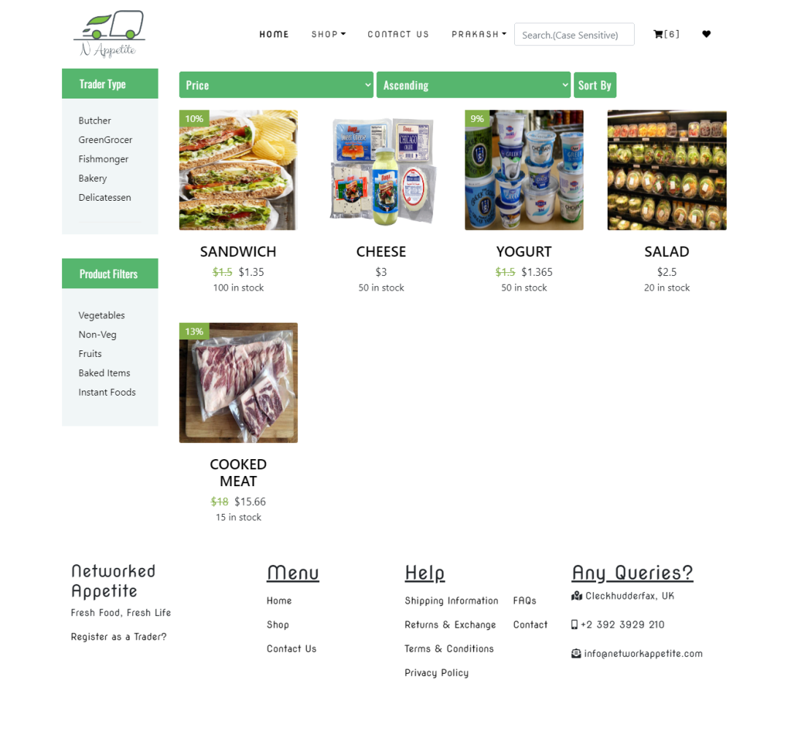

PRODUCT BY FOOD TYPE:

VEG: Clicking on vegetables shows veg products.

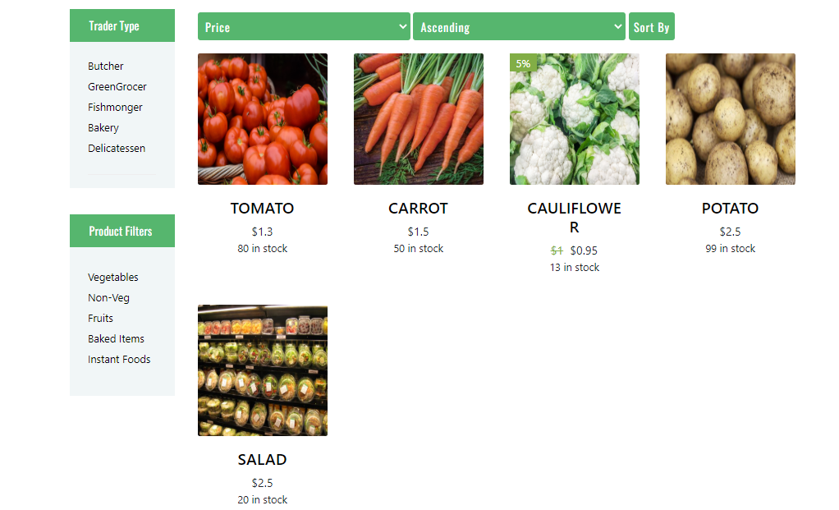

NON-VEG: Clicking On Non-Veg Filter shows non veg products like this.

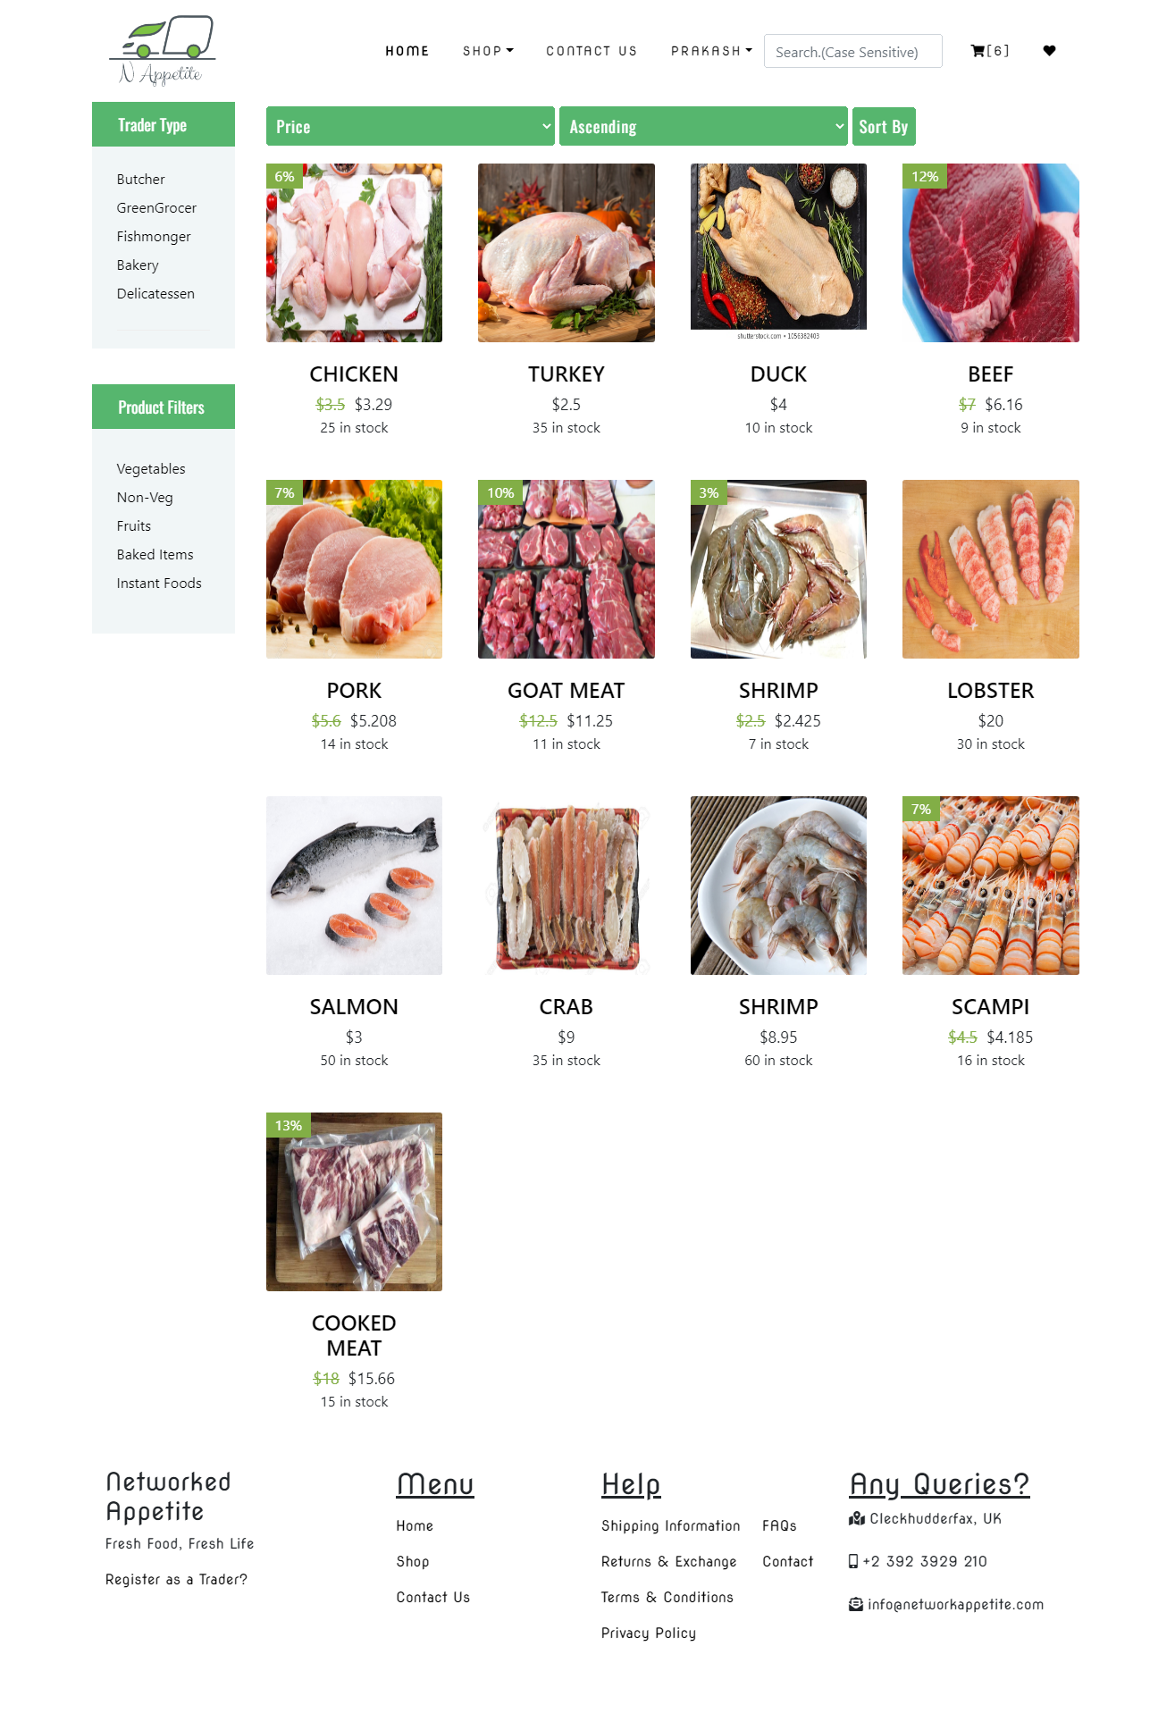

All other filters works like this.

Search Product: User can search for product by using search field in menu.

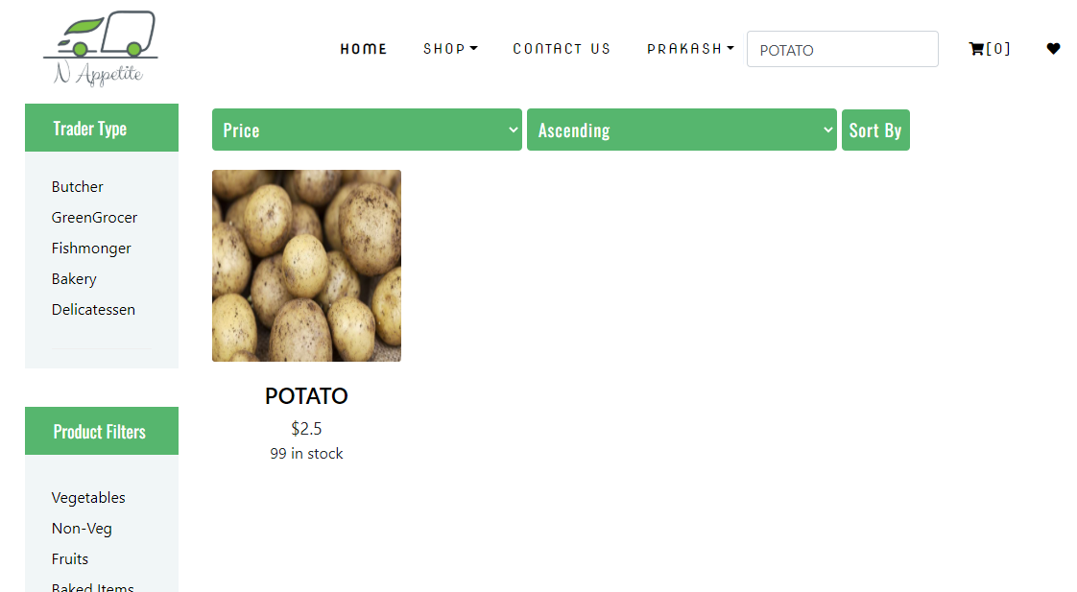

SINGLE PRODUCT:

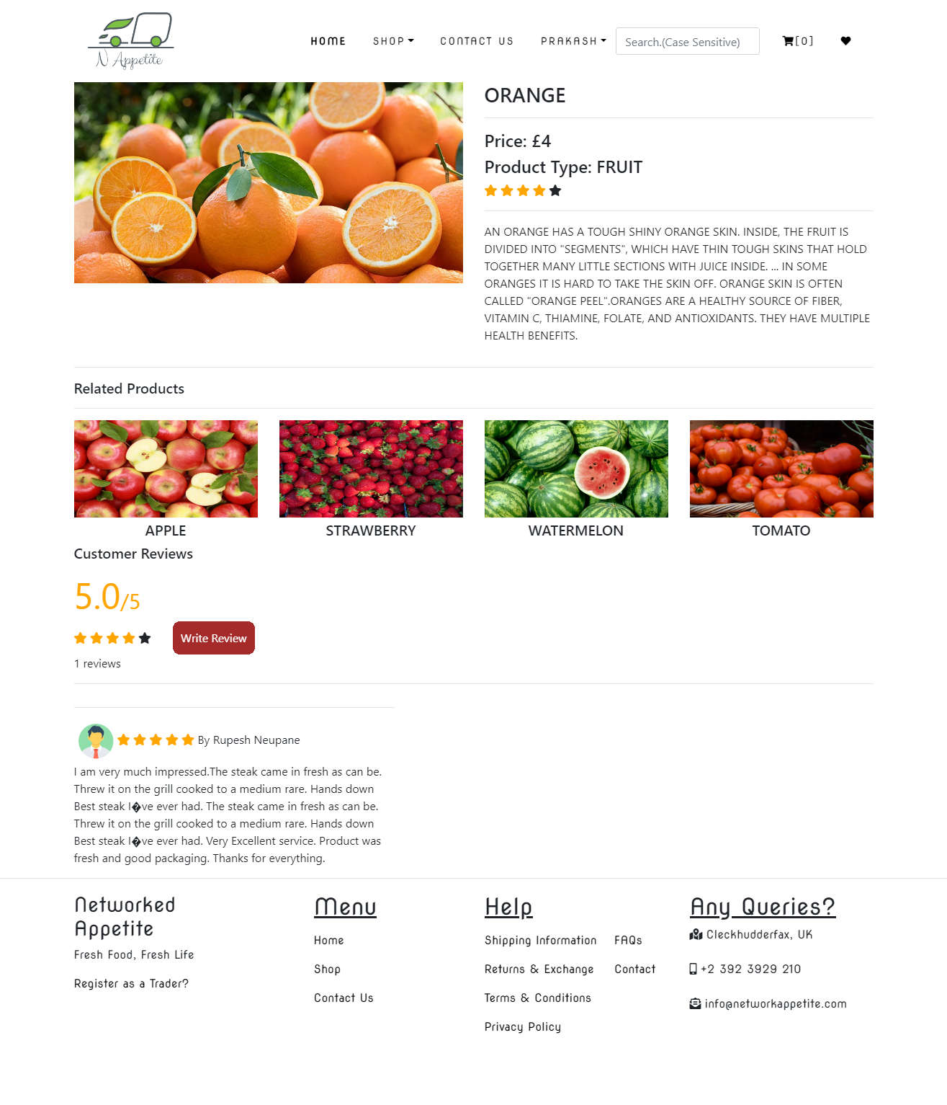

GIVING REVIEW AND RATING

Clicking on write review will open a form like this. User can give rating and write review about it.

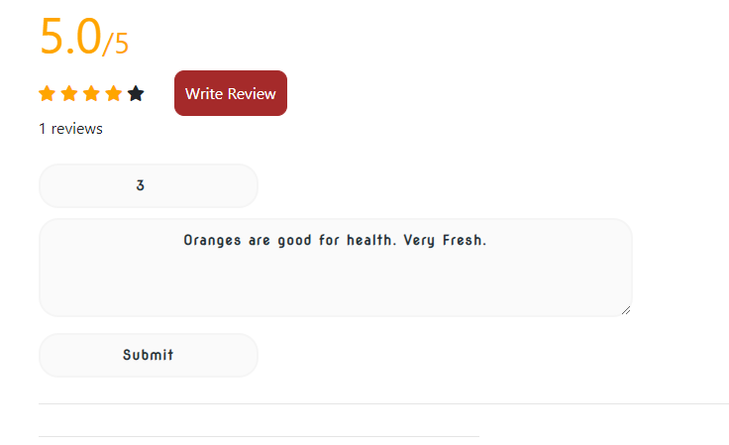

After giving review the rating and review is displayed below.

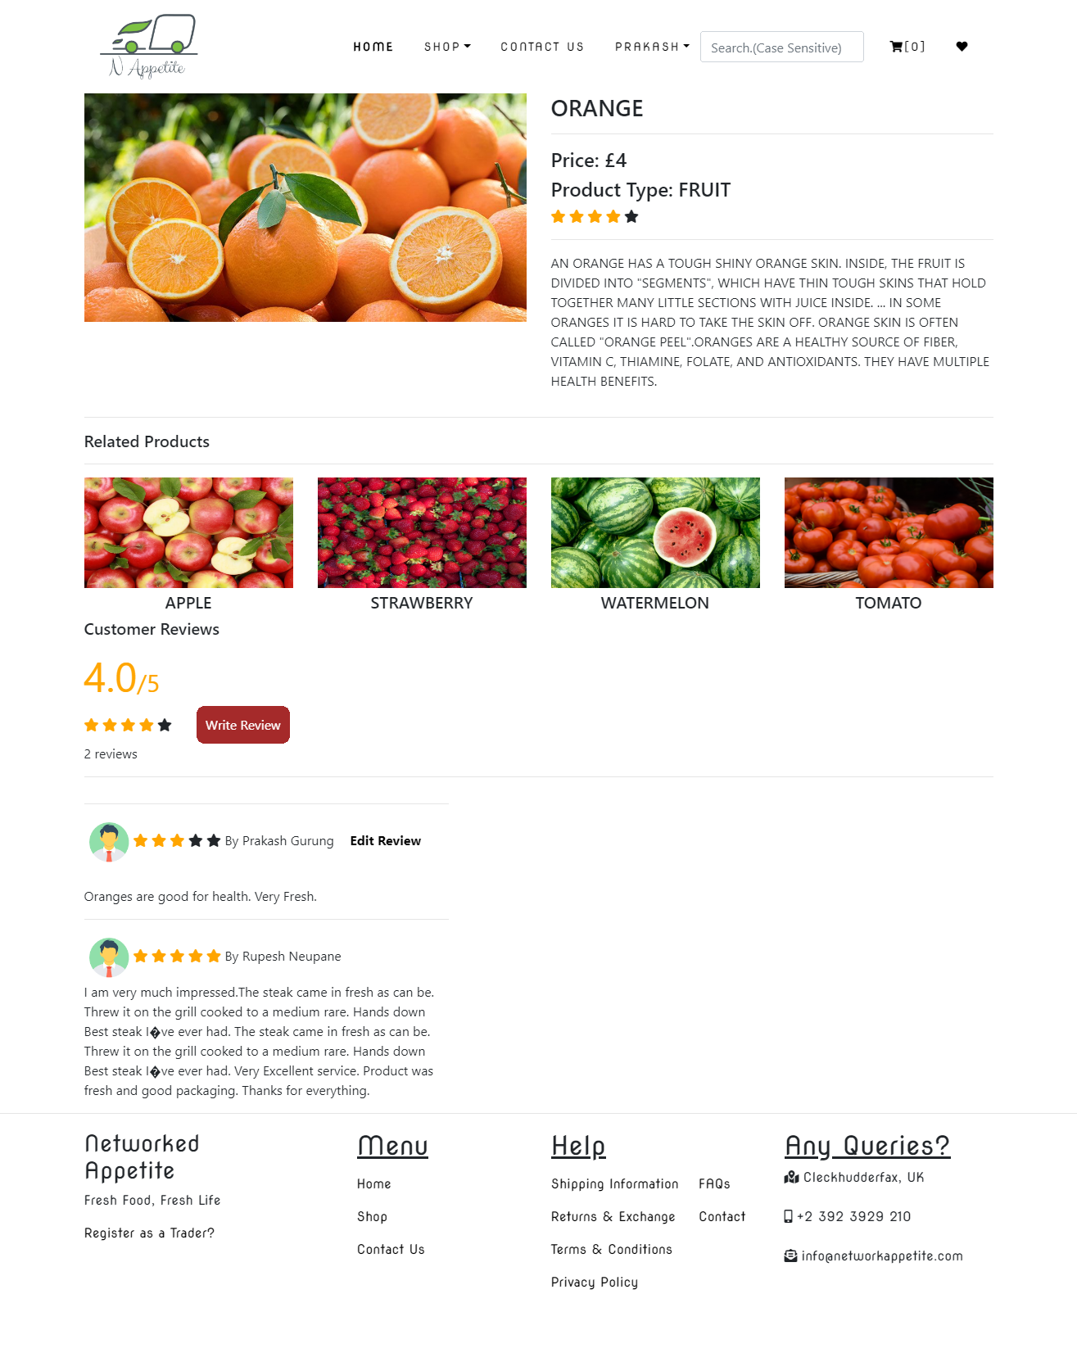

Add to Favourite: Click on the heart icon to add to favourite.

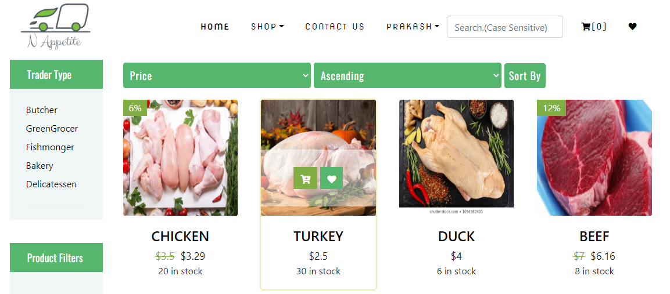

Favourite Page: Favourite products are shown in this page.

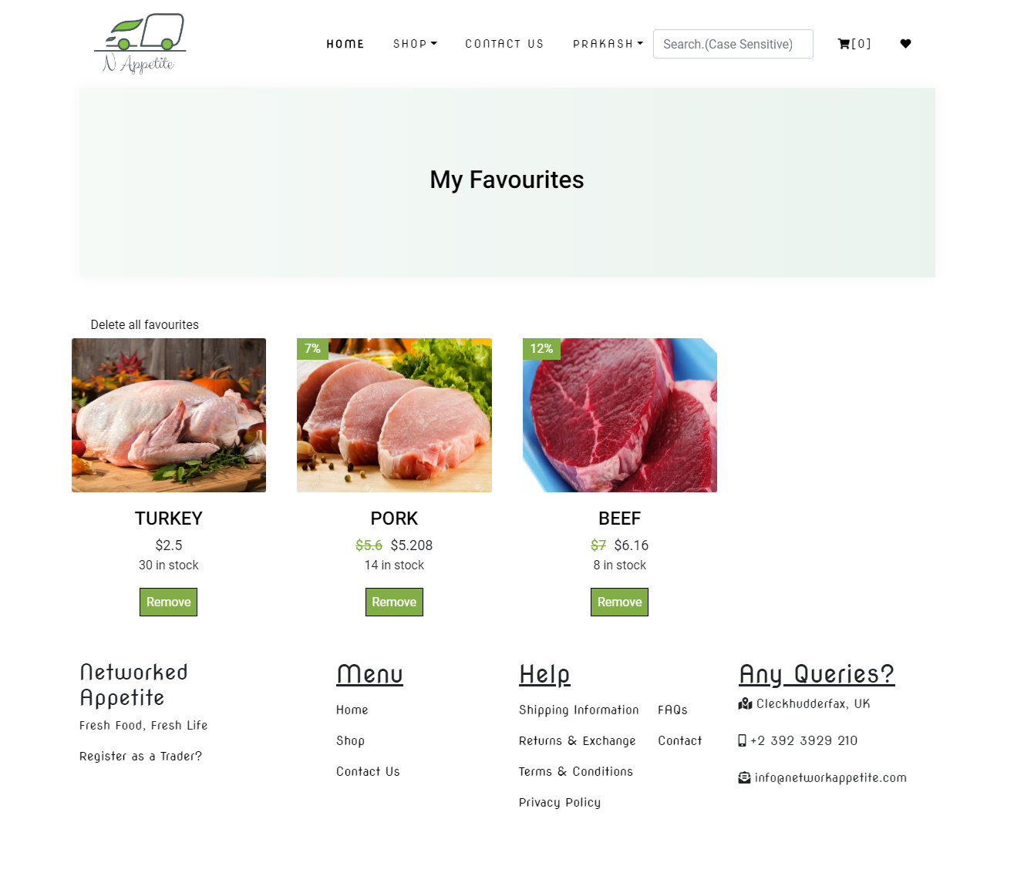

Add to CART:

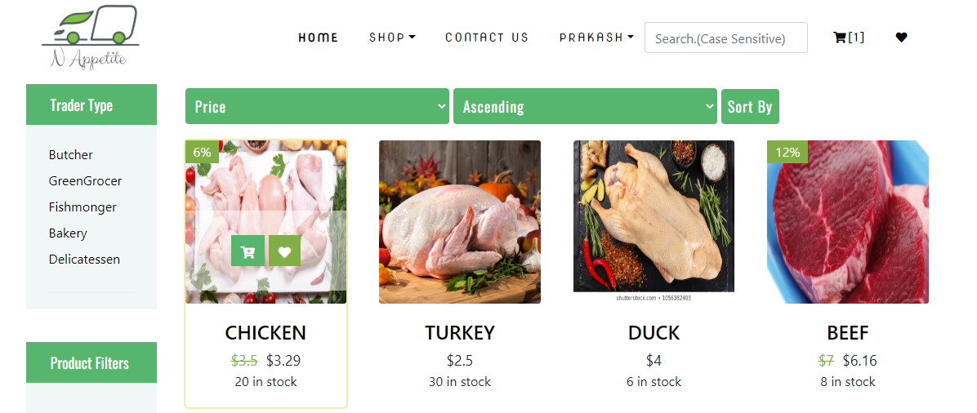

Cart:

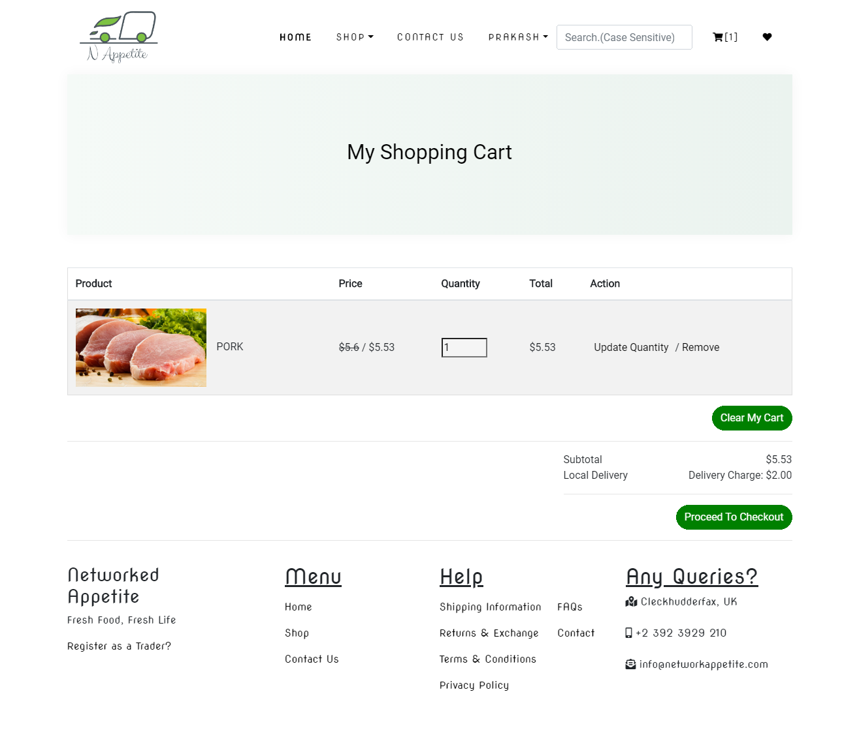

Clicking on proceed to checkout will redirect user to checkout page.

Here user has to give shipping details and then click on place order.

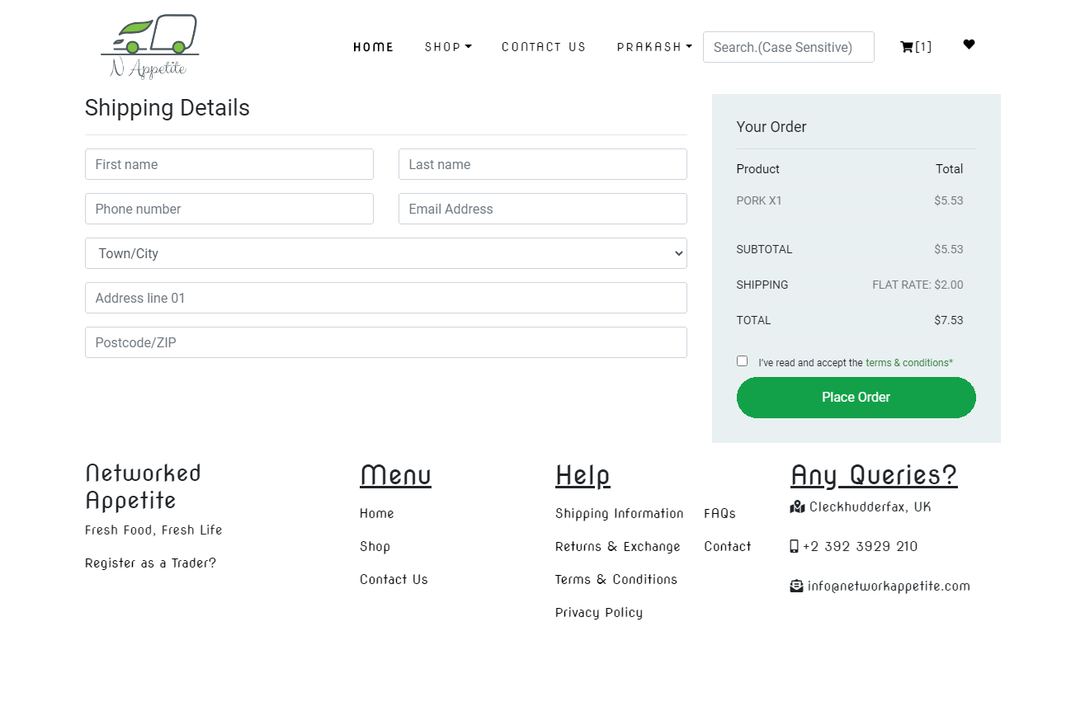

Then user will be redirected to PayPal payment while an email is sent to customer regarding order confirmation.

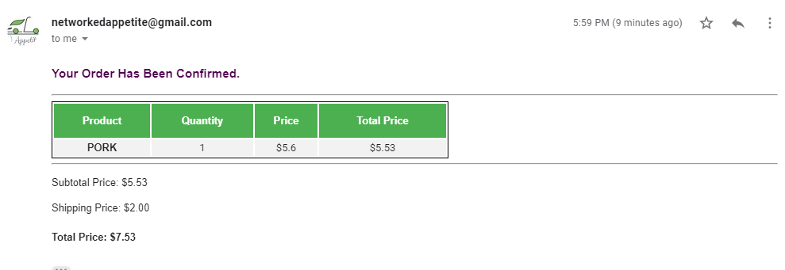

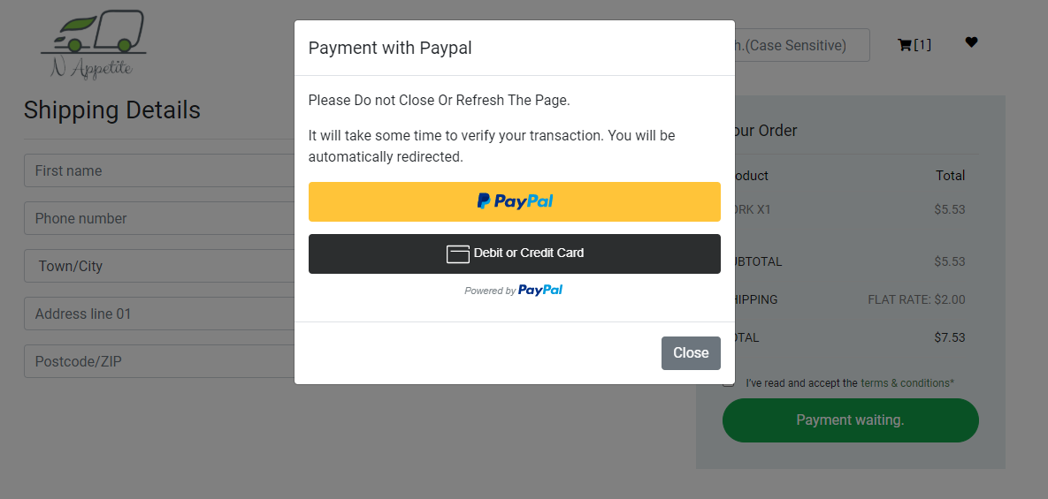

Clicking on PayPal Button Will Redirect User To PayPal Login Page

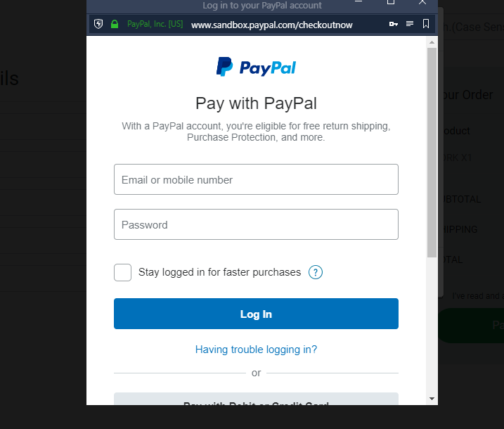

After this, this type will page will be shown and user will pay the bill.

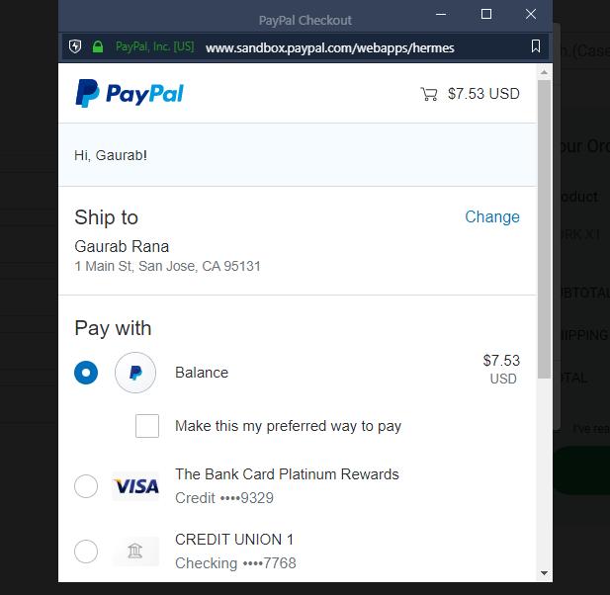

After payment, user will be redirected to this page where the order detail is shown and user is given option to choose those collection slots which are available after 24 hours of order placed.

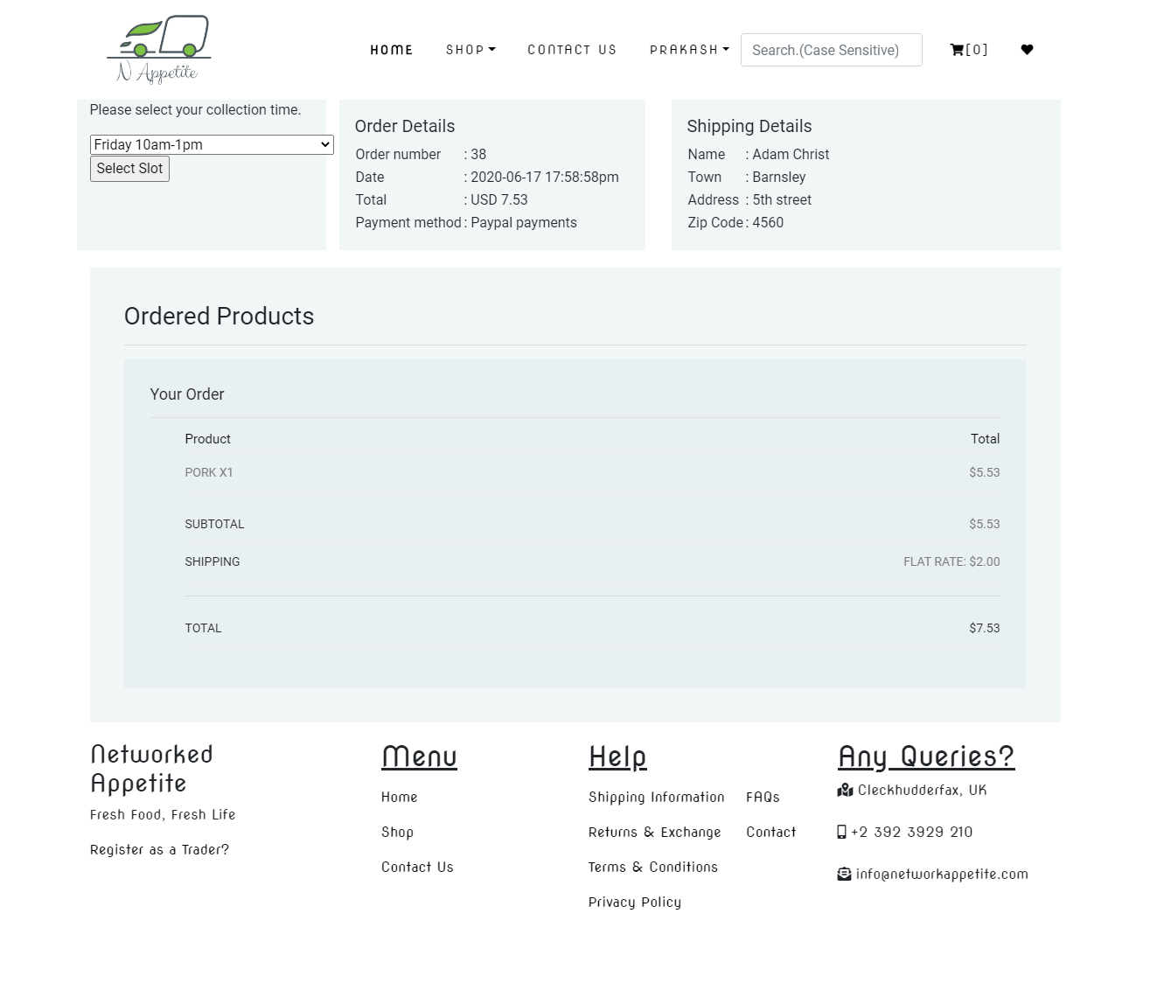

Side by side, user will get invoice of product bought.

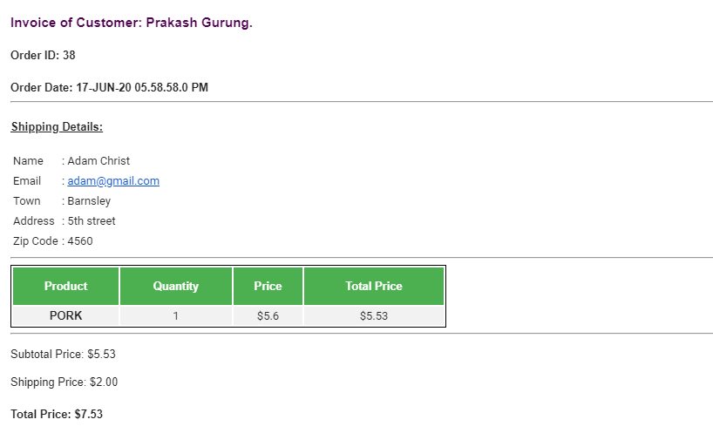

User Profile: Here user has 4 tabs. First tab shows detail of user.

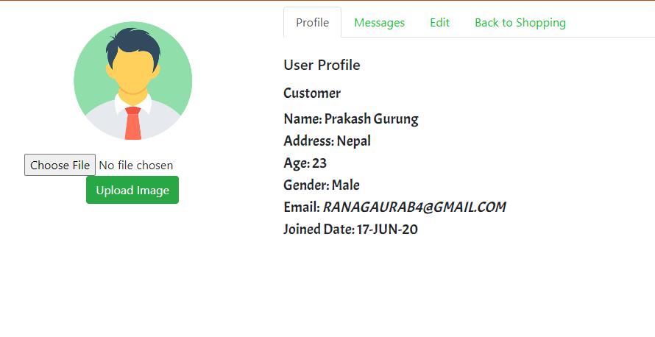

Second tab shows details of recent orders.

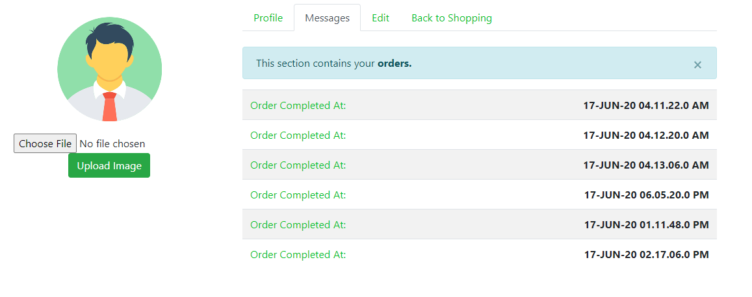

Edit tab allows user to update their profile.

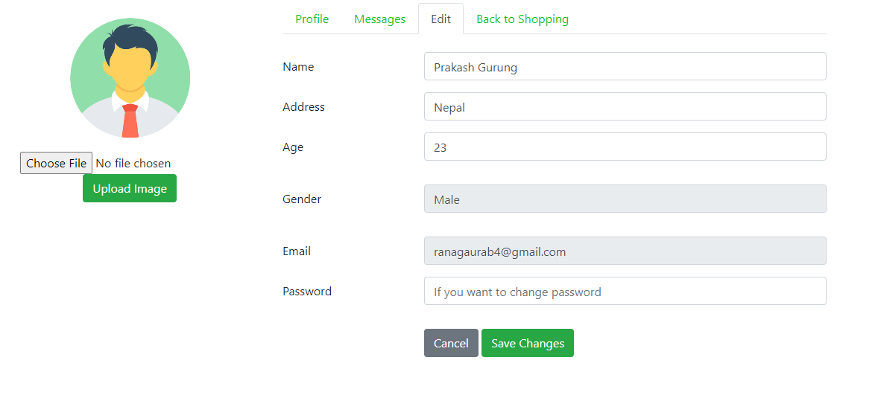

This completes the guideline.